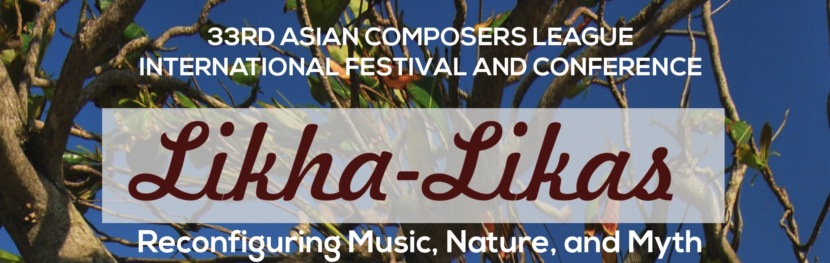
NOVEMBER 6, 2015 FRIDAY
CHORAL CONCERT 7:30 pm
COMPOSER | TITLE OF COMPOSITION | COUNTRY
Yuen, Viola | Lullaby | Hong Kong
Hattori, Kazuhiko | Yours | Japan
Taninaka, Suguru | Topology of Love | Japan
Othman, Johan | The Dancing Mouse | Malaysia
Wang, Chee-Wei | Weary | Malaysia
Ritchie, Anthony | Is it True? | New Zealand
Hamilton, David | Cancion de Invierno | New Zealand
Carey, Ross James | Tuk Tak Dung | New Zealand/Malaysia
Wood, Tiffany | Organer Mosen: Bodies of the Bog | New Zealand
Constantino, Bienvenido B., Jr. | Syatong | Philippines
Alcala, Nilo | Arimaonga | Philippines
Chao, Li-Wei | Wo (Prize winner commissioned pc) | Taiwan
Chien, Shan-Hua George | Ode to the Ocean | Taiwan
Juang, Wen-Ta | The Sound of Austronesia | Taiwan
Lam, Doming | Missa Laudis | Hongkong

NOVEMBER 7, 2015 SATURDAY 2:00 pm
(One Concert: ART SONG, ETHNO-POP, AND ELECTRONIC MUSIC)
ART SONGS
COMPOSER | TITLE OF COMPOSITION |  | COUNTRY
Vagner, Natalya | Breath |  | Australia
Scolnic, Vladimir | and If (Si Daca) |  | Israel
Loh, CH | A Queen A Mother |  | Malaysia
Tee, Xiao Xi | Life's Dukka (Shenghoubaku) |  | Malaysia
Rubio, Eric | Circus |  | Singapore
Sharpley, John | The Secret of Death |  | Singapore
Santos, Ramon | Mamasapano |  | Philippines
ETHNO-POP
Limjoco, Earl | Vibe With Me |  | Philippines
Aquino, Maverick Shawn | Strength of Dreams |  | Philippines
ELECTRONIC MUSIC

Sidarta, Otto | Saluang | Indonesia
Azizol, Ainolnaim | Meta VI (for electroacoustics) | Malaysia
Reyes, Dennis | Bolgia | Philippines
Koh, Joyce Beetuan | Grafitti II | Singapore
Tseng, Yu Chung | As Butterflies Flying Under the Curtain | Taiwan

NOVEMBER 7, 2015 SATURDAY 7:30 pm
YOUNG COMPOSERS PRIZE CONCERT
COMPOSER | TITLE OF COMPOSITION | COUNTRY
Smyth, Tyler | Purlieu's Ambit | Australia
Chun-Wai, Wong | Nhemamusasa | Hong Kong
Yu, Jinsol | Metamorphosis | Korea
Macahis, Feliz | Bardo | Philippines
Jonathan, Stevie | Music of Limitation | Indonesia
Nadav, Amir-Himmel | Baroque Concierto | Israel
Mukai, Hibiki | Tearing apart those wings | Japan
Sayyid, Muhammad | 人生行路 (Journey of Life) Jinesi Kouru | Malaysia
Blackmore, Callum | Seraphic Lucidities | New Zealand
Wang, Chien-Wei | Nirvana | Taiwan
Wee, Bertram | Love Songs | Singapore
Nongtrud, Onusa | Norah | Thailand
Ozdemir, Asim | String Quartet no. 2 | Turkey

NOVEMBER 8, 2015 SUNDAY 7:30 pm
LARGE ORCHESTRA CONCERT
COMPOSER | TITLE OF COMPOSITION | COUNTRY
Duncan, Eve | Approaching Venice | Australia
Do, Hong | Dialogue | Vietnam
Qiang, Wang | Intermezzo | China
Nechushtan, Alon | Tris-Megi-Stus | Israel
Matsushita, Isao | Tenku-no-Hikari (A Shining of Firmament) | Japan
Suk, Yoonbok | The 108 Passions | Korea
Chow, Junyi | Serenade | Malaysia
Liu, Alissa | The Corner of the War | New Zealand
Dagta, Jimuel Dave | Pulso | Philippines

NOVEMBER 9, 2015 MONDAY 1:30 pm
SYMPHONIC BAND CONCERT
COMPOSER | TITLE OF COMPOSITION | COUNTRY
Leung, Chi-hin | Reverberations From The Unreachable Continent | Hong Kong
Chan, David Ho-Yi | Reunion | Hong Kong
Ka-wai, So | Rite to Qinglong | Hong Kong
Kadowaki, Osamu | a dragon is flying in the sky | Japan
Fajardo, Erwin | Signal number 4: Pablo | Philippines
Lee, Kah Hong Bernard | 4 Canvass of Soo Pieng | Singapore
Tzeng, Shing-kwei | Dialogue Between Farmer and Dew | Taiwan
Sakulsurarat, Pasinee | One's Spiritual Home | Thailand
Pantura-umporn, Siraseth | UNTITLED 5/2550 | Thailand

NOVEMBER 9, 2015 MONDAY 8:00 pm
CHAMBER CONCERT I
COMPOSER | TITLE OF COMPOSITION | COUNTRY
Pertout, Andrián | Un brillo en la oscuridad | Australia
Shuen, Lai Yin | Rainscape (As a stream) | Hong Kong
Itazu, Shoryu | Dream Compression | Japan
Kang, Hoon | Crucifixion | Korea
Paik, Young-eun | The Song of Stars (Nocturne) | Korea
Ballard, Sarah | Felsic Mafic | New Zealand
Del Rosario, Conrado | Pine Whispers | Philippines
Talaroc, Jem | Salin sa Walay Kahangturan | Philippines
Balsamo, Jude Edgard | Untitled (for Violin and Piano) | Philipines
De Silva, Alicia Joyce | Stones Sand and Darkness | Singapore
Lin, Mei-Fang | Time Tracks | Taiwan
Ozdemir, Erman | Bias | Turkey

NOVEMBER 10, 2015 TUESDAY 1:30 pm
CHAMBER CONCERT 2
COMPOSER | TITLE OF COMPOSITION | COUNTRY
Hwang, Hye-Jeong | In Between | Korea
Liu, Po-Chien | Illusion | Taiwan
Hong Da, Chin | Clock is ticking | Malaysia
Weng, Yu Ting | Before Consciousness | Taiwan
Feliz. Juro Kim | Gandingan sa Kagiliran | Philippines
Ung, Chinary (Guest Composer) | Spiral IX (Mother & Child) | Cambodia
Amar Talia | Prismatic Spectrum | Israel
Muyco, Maria Christine | Agit-it | Philippines

NOVEMBER 11, 2015 WEDNESDAY 8:00 pm
Multi-Media Concert
COMPOSER | TITLE OF COMPOSITION | COUNTRY
Chu, Priscila | Halika Dito (Come here, I am waiting for you) | Hong Kong
Momiyama, Tomoko | Untitled | Japan
Willis, Peter | Ritual Recipe Remixed | New Zealand
Baes, Jonas | Wala | Philippines
Casteels, Robert, Dr. | Salapa’ | Singapore
Awarding and Closing Ceremony

